AI-Powered Autonomous Plant Care System

Summary
This project develops a comprehensive, low-cost, fully offline AI-driven system for autonomous plant care. The system continuously monitors environmental conditions using four specified sensors — MQ135 (Air Quality/CO₂ & pollutants), Rain Sensor, DHT11 (Temperature & Humidity), and BMP180 (Air Pressure & Altitude) — and automatically controls actuators such as a water pump, fan, and LED grow lights.
Data is collected by an Arduino microcontroller and transmitted via USB serial to a laptop-based AI Agent. The agent, powered by Ollama + Llama 3.2 (or Llama 3 8B) and orchestrated with LangChain + LangGraph, performs advanced reasoning including:
- Real-time Plant Health Scoring (0–100 scale)
- Predictive Care (forecasting stress in X hours using historical trends)
- Daily Care Plan generation
- Memory System for learning from past patterns
- Explainable AI with clear decision justifications
- Self-Healing, Adaptive Scheduling, and Feedback Loop mechanisms
Unique Differentiator: A fully offline conversational Voice Agent with a lively Plant Persona. The plant “speaks” in first person (e.g., “I’m feeling thirsty today… please give me some water”) using Vosk (Speech-to-Text) and Piper TTS (Text-to-Speech). Users can ask questions like “How is my plant?” or give voice commands like “Turn on the fan.”
The entire system operates offline by default, requires no internet after initial setup, and is designed for long-term reliability with safety limits (e.g., maximum 10-second pump runtime). Estimated hardware cost (excluding laptop): under ₹3,500. The architecture draws inspiration from the Claude “Sol” tomato plant project while adding advanced predictive, memory, and voice capabilities

Problem Statement
Healthy plant growth depends on precise, continuous management of multiple interdependent environmental variables. Even small deviations — such as temperature rising above 28°C while humidity drops below 50% or air quality deteriorating due to high CO₂/pollutants — can cause physiological stress, reduced photosynthesis, wilting, or disease within hours.
Traditional manual monitoring is inconsistent and time-consuming. Existing commercial smart planters are often expensive (₹8,000–₹30,000+), heavily cloud-dependent (raising privacy, latency, and connectivity issues), and limited in intelligence. Most lack predictive analytics, historical learning, explainable decisions, or natural human-like interaction.
There is a clear need for an affordable, fully offline, highly intelligent system that:
- Accurately monitors the four specified sensors in real time
- Calculates a quantitative Plant Health Score
- Predicts future stress using trend analysis
- Generates adaptive daily care schedules
- Maintains memory of sensor patterns and action outcomes
- Provides transparent, explainable reasoning
- Offers engaging voice-based interaction through a living Plant Persona
- Self-heals from sensor failures and dynamically adjusts its behavior

Objectives
Primary Objectives
- Build a reliable hardware-software loop using Arduino for sensor reading/actuator control and Python for AI decision-making.
- Maintain optimal environmental conditions for a typical plant (e.g., tomato): Temperature 20–25°C, Humidity 50–70%, Air Quality <500 PPM (MQ135 reading).
- Ensure bidirectional USB serial communication with robust error handling.
- Achieve 24/7 autonomous operation with minimum 30-day reliability target.
Advanced Intelligence Objectives
5. Compute a Plant Health Score (0–100) every cycle using a weighted formula (Temperature deviation: 40%, Humidity deviation: 30%, Air Quality: 20%, Rain/Pressure factors: 10%) refined by LLM reasoning.
6. Implement Predictive Care to forecast potential stress (e.g., “Plant may become stressed in 4–6 hours”) based on historical trends and rate-of-change analysis.
7. Generate a Daily Care Plan (watering times, light cycles, fan usage) after collecting 24–48 hours of data.
8. Develop a Memory System that stores sensor readings, actions taken, and outcomes for context-aware decisions.
9. Enable Explainable AI — the system must justify every action (e.g., “I turned on the fan because air quality reached 850 PPM and temperature was rising”).
10. Create a Voice Agent with Plant Persona supporting speech input (Vosk) and natural speech output (Piper TTS) in first-person conversational style.
11. Incorporate Self-Healing (fallback to last valid data on sensor errors), Adaptive Scheduling (check frequency adjusts from 5 min during stress to 60 min when stable), and a Feedback Loop (evaluate post-action improvement and learn preferences).
Secondary Objectives
12. Log all data, scores, predictions, actions, and explanations in a structured CSV/SQLite format.
13. Support optional critical alerts (console + Telegram integration).
14. Design the system for easy future expansion (e.g., soil moisture sensor, camera)

Proposed Solution
The system follows a modular, layered edge-computing architecture optimized for reliability and offline performance.
Hardware Layer (Arduino Uno/Mega – C++)
- Sensor integration: MQ135 (A0), Rain (A1), DHT11 (Digital Pin 2), BMP180 (I2C).
- Data formatting into a single string (e.g., TEMP:25.3,HUM:62,AIR_QUAL:420,RAIN:DRY,PRESSURE:1012.5,ALT:148).
- Actuator control via 4-channel relay module (pins 8–10) with built-in safety timeouts.
- Periodic reading every 15–60 minutes (configurable).
Communication Layer
- USB Serial at 9600 baud – simple, reliable, bidirectional text protocol.
AI Agent Layer (Laptop – Python 3.10+ with LangChain + LangGraph)
- Receives and parses sensor data.
- Calculates base health score using weighted deviation formula.
- Uses LangGraph state machine for orchestration, memory management, and conditional workflows (e.g., predictive analysis → plan generation → action).
- Maintains short-term (conversation buffer) and long-term memory (vector store or SQLite).
- Handles voice interface as a parallel tool.
Voice Layer (Offline)
- Speech-to-Text: Vosk API with a compact English model (e.g., vosk-model-en-us-0.22) for low-latency command recognition and queries.
- Text-to-Speech: Piper TTS with a medium-quality voice model (e.g., en_US-lessac-medium) for natural, fast synthesis.
- Plant Persona: System prompt defines the AI as the plant itself (“You are Luna, a living tomato plant. Speak warmly in first person…”).
AI Core
- Primary: Ollama + Llama 3.2 (balanced speed/quality).
- Structured outputs enforced via LangChain Pydantic parsers for scores, predictions, and plans.
- Optional cloud fallback: Hugging Face Inference API.
Key Data Flows
- Sensor → Arduino → Serial → Python Agent
- Agent → Health Score + Prediction + Plan → Decision → Command → Arduino
- Voice → Vosk → Agent → Piper Response (with persona)
Sample Outputs
- Health Score: {"health_score": 78, "reason": "Temperature slightly elevated; air quality excellent."}
- Voice: “Hi! I’m Luna. My leaves feel a bit warm today. Could you turn on the fan for me?”

Requirements
5.1 Hardware Requirements
- Microcontroller: Arduino Uno or Mega
- Sensors: MQ135, Rain sensor, DHT11, BMP180
- Actuators: 5V submersible water pump + relay, DC fan + relay, LED grow light strip + relay
- Prototyping: Breadboard, jumper wires, 5V/2A power supply, USB cable
5.2 Software & Tech Stack Requirements
- Firmware: Arduino IDE + C++ (DHT library, Adafruit_BMP085 library)
- Backend: Python 3.10+
  - Communication: pyserial
  - Scheduling & Logging: schedule, pandas
  - AI Orchestration: langchain, langchain-community, langgraph, langchain-ollama
  - Voice: vosk (with offline model), piper-tts (or piper voice Python bindings)
  - Analysis: statsmodels (trend analysis)
  - Optional Alerts: python-telegram-bot
- LLM: Ollama with Llama 3.2 8B (or 3B variant for lighter laptops)
- Storage: CSV (initial) → SQLite for memory and history
5.3 Functional Requirements (Detailed)
- Sensor data transmission in strict key:value format with error handling (ERROR or -999).
- Plant Health Score calculation every cycle with weighted formula + LLM refinement.
- Predictive output must include estimated time-to-stress based on trend analysis.
- Daily Care Plan generation after minimum 24 hours of logged data.
- Voice Agent must support at least 5 core commands/queries with Plant Persona.
- All decisions must include an explanation string.
- Self-healing: On invalid data, fallback to last valid reading + safe default action.
- Adaptive scheduling: Interval dynamically adjusted between 5–60 minutes based on health score.
5.4 Non-Functional Requirements
- Fully offline operation (voice, LLM, and core logic).
- End-to-end cycle time < 10 seconds under normal conditions.
- Safety: Pump runtime capped at 10 seconds per activation.
- Reliability: Self-recovery from Arduino resets or sensor glitches.
- Resource usage: Compatible with mid-range laptops (8GB+ RAM recommended).
- Cost: Hardware < ₹3,500. Scalability for multi-plant support.

Implementation Approach (Phased)
Phase 1: Foundation — Arduino wiring, basic serial communication, simple Python agent, and logging.
Phase 2: Intelligence Core — Health scoring, memory system, predictive analysis, and LangGraph orchestration.
Phase 3: Daily Planning & Explainability — Structured LLM outputs and care plan generation.
Phase 4: Voice Agent — Integrate Vosk + Piper with Plant Persona prompt.
Phase 5: Autonomy — Self-healing logic, adaptive scheduling, and feedback loop evaluation.
Phase 6: Testing & Deployment — 72-hour continuous runs, edge-case testing, background service setup (tmux/NSSM).

Workflow Diagram
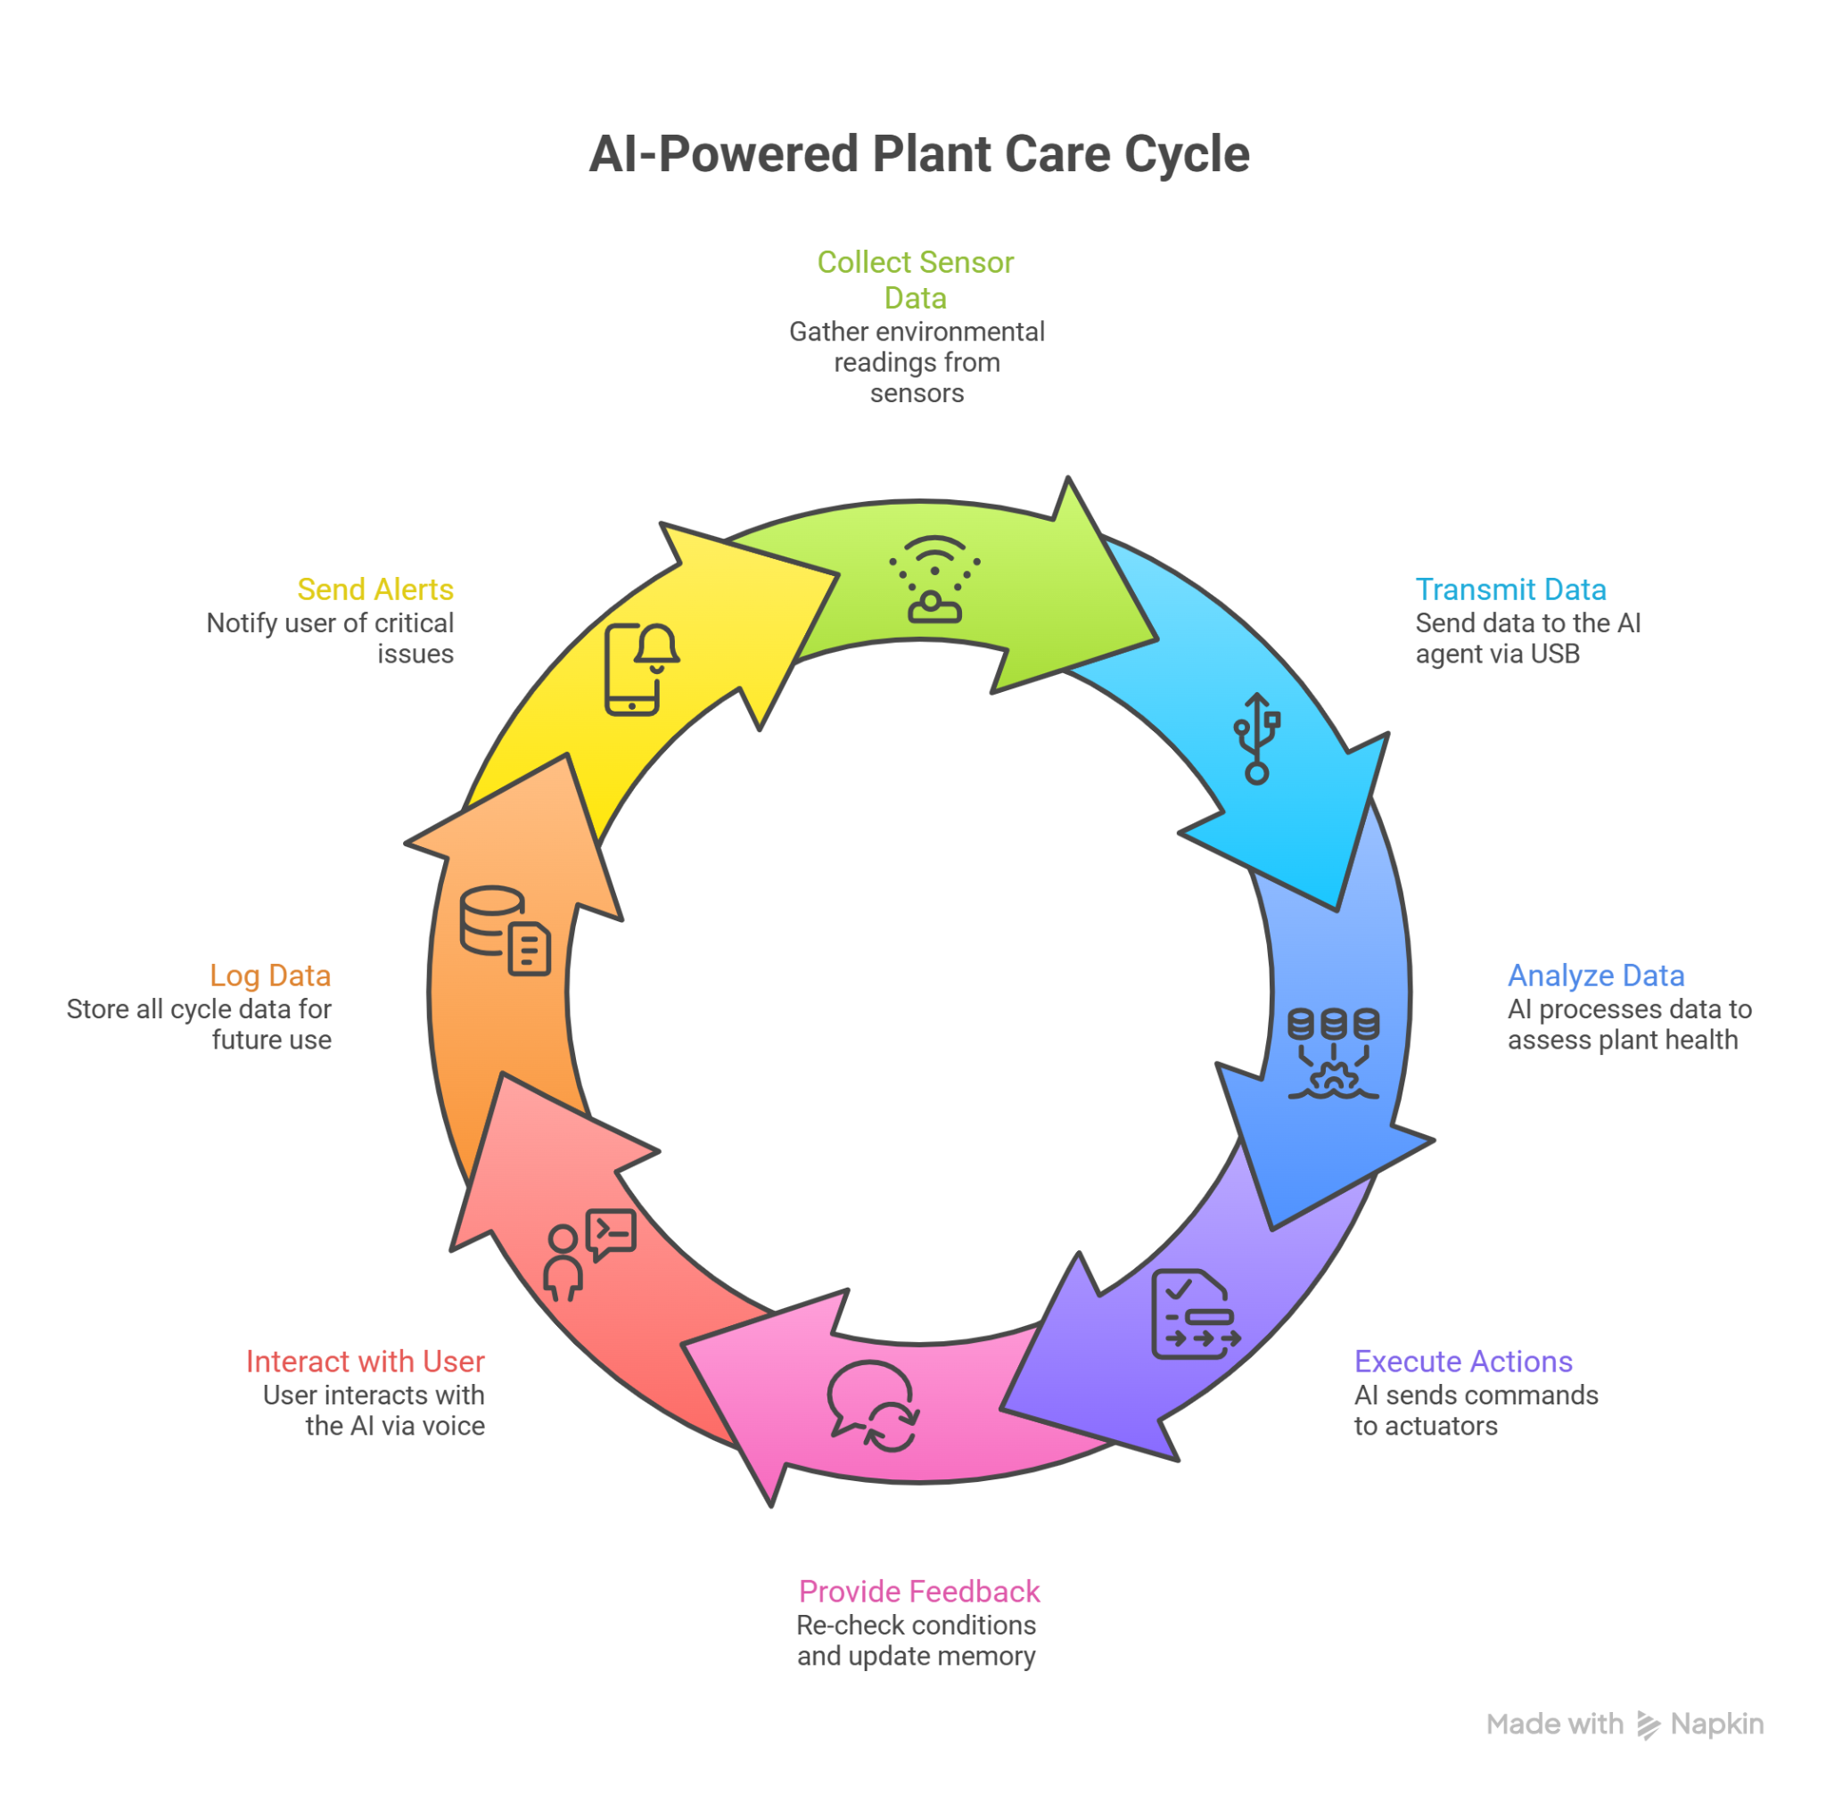

Architecture Diagram

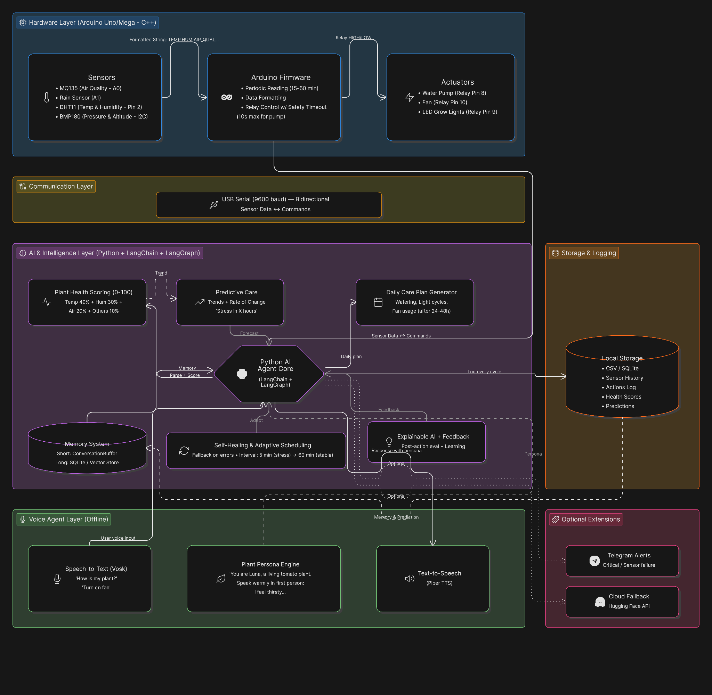

Risk Analysis & Mitigation
- Sensor failure or noisy readings → Self-healing fallback + last-valid-data logic.
- LLM inconsistent output → Strict Pydantic structured parsing in LangChain.
- Voice recognition errors → Confidence threshold + text fallback mode.
- Resource overload → Adaptive interval + lighter model option.
- Over-actuation → Hard-coded safety limits on Arduino side.

Future Scope & Enhancements
- Integration of additional sensors (soil moisture, camera for visual health).
- Fine-tuning the LLM on collected plant-specific dataset.
- Multi-plant support with individual IDs and personas.
- Mobile/web dashboard and push notifications.
- Solar-powered standalone edge device version.

References
- Claude AI “Sol” Tomato Plant Project on X (@d33v33d0) – real-world inspiration for autonomous AI agent control
- Ollama & Llama 3.2 Documentation
- LangChain / LangGraph Official Guides (stateful agents, human-in-the-loop)
- Vosk Offline Speech Recognition API
- Piper TTS Documentation and Python bindings
- Arduino Sensor Libraries & Best Practices
- Plant Science References on VPD, temperature-humidity interactions, and environmental monitoring

